Charlie Nitschelm

10/1/18

Thermal Systems HW #4

# Quantify and Compare Refrigeration Cycles

# Table of Values

|  |  |  |  |
| --- | --- | --- | --- |
| COP_Summer | COP_Winter | Mass_Flow_Summer (kg/s) | Mass_Flow_Winter (kg/s) |
| 4.82 | 10.5 | .030 | .025 |

|  |  |
| --- | --- |
| Compressor_Power_Summer (J/s) | Compressor_Power_Winter (J/s) |
| 1,037 | 475.4 |

## Description of Values

From the values calculated above, we are able to analyze the outcome of the refrigeration cycle during the Summer and Winter months in Durham, NH. The outside environment during the summer months was calculated to be 303 Kelvin, while the winter was 283 Kelvin. From this difference in outside temperature, it changed the overall refrigeration cycle, altering heavily the COP, Mass Flow Rate needed, and the compressor power. The data shows that the COP from the summer to the winter more than doubles when the outside temperature is closer to the temperature desired for cooling. By having a better COP, it is expected that the mass flow rate needed decreases to still maintain the same desired cooled temperature. This also alters the required power the compressor needs to experience, allowing the amount of J/s to decrease in the winter months due to less of a temperature difference from the outside environment. The graphs below detail the overall cycle change for the variation of outside temperatures Durham, NH could encounter during a whole year.  
  
 =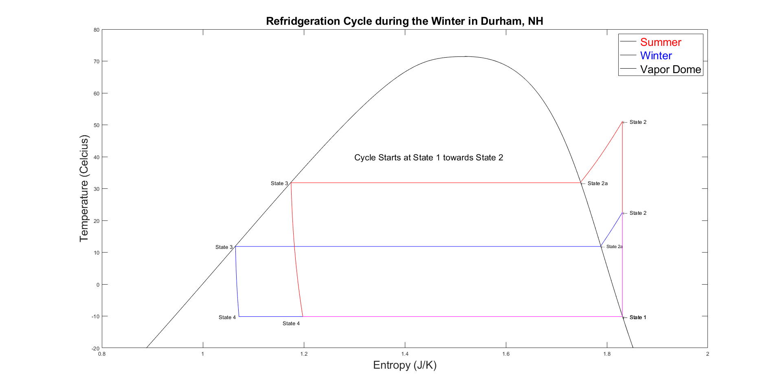

Figure 1- The Temperature vs. Entropy graph for two different refrigeration cycles during the Summer and Winter months in Durham, NH.

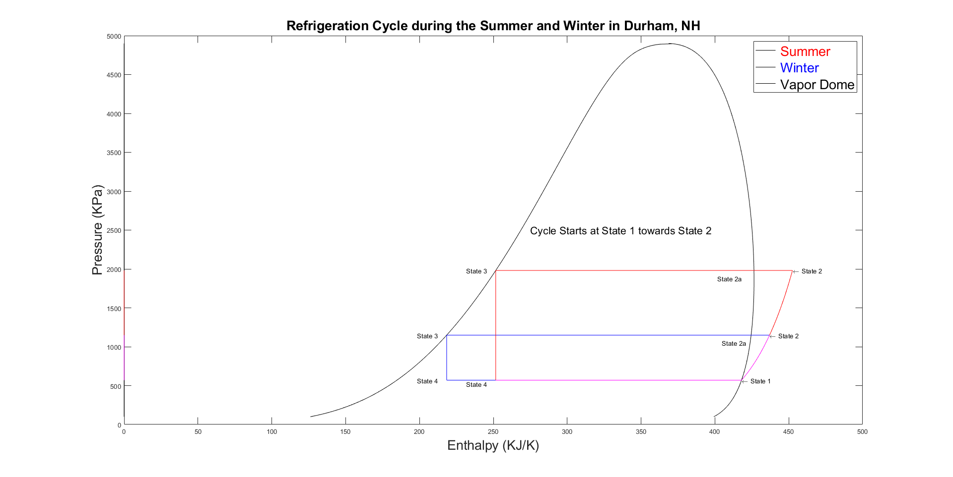

Figure 2- The Pressure vs. Enthalpy graph for two different refrigeration cycles during the Summer and Winter months in Durham, NH.

# MATLAB CODE

clear all; close all

clc;

%Problem Statement

% %A refrigerator in a meat warehouse located in Durham, NH has a cooling capacity of 5kW. It must maintain

% the cold space at -15?C throughout the entire year. Quantify and compare the flow rate required, compressor

% power, and coefficient of performance (COP) for the best and worst case scenarios, assuming an ideal, standard

% vapor compression refrigeration cycle with ?TL = 5?C and ?TH = 2?C. Plot the two scenarios on both a T-s

% and a P-h diagram (include the vapor dome). Label the state points and indicate the cycle direction. Note that

% ?TL and ?TH refer to the temperature differences between the cycle and environments needed for the heat transfer.

% Please submit a single pdf file with the solution. You need to include all the figures and the entire code in the file.

% The code should follow the solution.

%%%%%%%%%%%%%

% Constants for the Refridgeration Cycle for Durham, NH

%%%%%%%%%%%%%

T_L = 5; % Kelvin - Amount of temperature away from the Evaporator Process

T_H = 2; % Kevlin - Amount of temperature away from the second part of the Condensor Process

Cold_Space = 273-15; % Kelvin - Temperature of Cold Space of Refridgerator

Hot_Space_Summer = 273 + 30; % Hottest recorded temperature of Durham NH in the Summer

Hot_Space_Winter = 273 + 10; % Hottest recorded temperature of Durham NH in the Winter

T_Outside = linspace(250,Hot_Space_Summer,1000); % Kelvin - Record high and low temperatures in Durham that the outside temperature would reach, 1000 Length Array

%%%%%%%%%%%%%

% Location 1 - Between Evaporator and Compressor

%%%%%%%%%%%%%

% Finding all values of the fluid at location 1

Q_1 = 1; % Saturated Vapor

T_1 = Cold_Space + T_L; % Temperature from 4 to 1

P_1 = CoolProp.PropsSI('P', 'T', T_1, 'Q', Q_1, 'R410a');

H_1 = CoolProp.PropsSI('H', 'T', T_1, 'Q', Q_1, 'R410a');

U_1 = CoolProp.PropsSI('U', 'T', T_1, 'Q', Q_1, 'R410a');

S_1 = CoolProp.PropsSI('S', 'T', T_1, 'Q', Q_1, 'R410a');

%%%%%%%%%%%%%

% Location 3 - Between Condensor and Expansion Valve - Saturated Liquid

%%%%%%%%%%%%%

% Finding all values of the fluid at location 3

Q_3 = 0; % Saturated Liquid

T_3_Summer = Hot_Space_Summer + T_H; % Temperature from 4 to 1

P_3_Summer = CoolProp.PropsSI('P', 'T', T_3_Summer, 'Q', Q_3, 'R410a');

H_3_Summer = CoolProp.PropsSI('H', 'T', T_3_Summer, 'Q', Q_3, 'R410a');

U_3_Summer = CoolProp.PropsSI('U', 'T', T_3_Summer, 'Q', Q_3, 'R410a');

S_3_Summer = CoolProp.PropsSI('S', 'T', T_3_Summer, 'Q', Q_3, 'R410a');

T_3_Winter = Hot_Space_Winter + T_H; % Temperature from 4 to 1

P_3_Winter = CoolProp.PropsSI('P', 'T', T_3_Winter, 'Q', Q_3, 'R410a');

H_3_Winter = CoolProp.PropsSI('H', 'T', T_3_Winter, 'Q', Q_3, 'R410a');

U_3_Winter = CoolProp.PropsSI('U', 'T', T_3_Winter, 'Q', Q_3, 'R410a');

S_3_Winter = CoolProp.PropsSI('S', 'T', T_3_Winter, 'Q', Q_3, 'R410a');

%%%%%%%%%%%%%

% Location 2 - Between Condensor and Expansion Valve Super-Heated Vapor

%%%%%%%%%%%%%

% Finding all values of the fluid at location 2

S_2_Summer = S_1; % Constant Entropy

P_2_Summer = P_3_Summer; % Constant Pressure Isobar

T_2_Summer = CoolProp.PropsSI('T', 'P', P_2_Summer, 'S', S_2_Summer, 'R410a');

H_2_Summer = CoolProp.PropsSI('H', 'P', P_2_Summer, 'S', S_2_Summer, 'R410a');

U_2_Summer = CoolProp.PropsSI('U', 'P', P_2_Summer, 'S', S_2_Summer, 'R410a');

P_2_Winter = P_3_Winter; % Constant Pressure Isobar

S_2_Winter = S_1; % Constant Entropy

T_2_Winter = CoolProp.PropsSI('T', 'P', P_2_Winter, 'S', S_2_Winter, 'R410a');

H_2_Winter = CoolProp.PropsSI('H', 'P', P_2_Winter, 'S', S_2_Winter, 'R410a');

U_2_Winter = CoolProp.PropsSI('U', 'P', P_2_Winter, 'S', S_2_Winter, 'R410a');

%%%%%%%%%%%%%

% Location 2a - On Vapor Dome During the process 2 to 3 in condensor

%%%%%%%%%%%%%

% Finding all values of the fluid at location 2a

Q_2a=1; % On Vapor Dome as Saturdated Vapor

P_2a_Summer = P_2_Summer; % Isobar = Constant Pressure

T_2a_Summer = T_3_Summer; % Constant Temperature from T3

S_2a_Summer = CoolProp.PropsSI('S', 'P', P_2a_Summer, 'Q', Q_2a, 'R410a');

H_2a_Summer = CoolProp.PropsSI('H', 'P', P_2a_Summer, 'Q', Q_2a, 'R410a');

U_2a_Summer = CoolProp.PropsSI('U', 'P', P_2a_Summer, 'Q', Q_2a, 'R410a');

P_2a_Winter = P_2_Winter; % Isobar = Constant Pressure

T_2a_Winter = T_3_Winter; % Constant Temperature from T3

S_2a_Winter = CoolProp.PropsSI('S', 'P', P_2a_Winter, 'Q', Q_2a, 'R410a');

H_2a_Winter = CoolProp.PropsSI('H', 'P', P_2a_Winter, 'Q', Q_2a, 'R410a');

U_2a_Winter = CoolProp.PropsSI('U', 'P', P_2a_Winter, 'Q', Q_2a, 'R410a');

%%%%%%%%%%%%%

% Location 4 - Mixture between the expansion valve and evaporator

%%%%%%%%%%%%%

% Finding all values of the fluid at location 4

T_4 = T_1; % Constant Temperature from 4 to 1 Process

H_4_Summer = H_3_Summer; % Expansion Valve is ~ constant enthalpy process

P_4_Summer = P_1; % Isobaric Process

U_4_Summer = CoolProp.PropsSI('U', 'P', P_4_Summer, 'H', H_4_Summer, 'R410a');

S_4_Summer = CoolProp.PropsSI('S', 'P', P_4_Summer, 'H', H_4_Summer, 'R410a');

H_4_Winter = H_3_Winter; % Expansion Valve is ~ constant enthalpy process

P_4_Winter = P_1; % Isobaric Process

U_4_Winter = CoolProp.PropsSI('U', 'P', P_4_Winter, 'H', H_4_Winter, 'R410a');

S_4_Winter = CoolProp.PropsSI('S', 'P', P_4_Winter, 'H', H_4_Winter, 'R410a');

%%%%%%%%%%%%%

% Calculations of the Vapor Dome for the Refridgeration Cycle

% Will be plotted as a T-s and P-h Diagram

% Two curves will be plotted for each graph, one for the Saturated Liquid and one for Saturdated Vapor Sections

%%%%%%%%%%%%%

% Constant Variables and Pressure Array to Calculate Graph Values

Q_SL = 0; % Saturated Liquid

Q_SV = 1; % Saturated Vapor

P_SL_SV = linspace(100000,4900000,1000); % Pressures for the Saturated Liquid Curve

T_SL = zeros(length(P_SL_SV));

S_SL = zeros(length(P_SL_SV));

H_SL = zeros(length(P_SL_SV));

T_SV = zeros(length(P_SL_SV));

S_SV = zeros(length(P_SL_SV));

H_SV = zeros(length(P_SL_SV));

% Looping 1000 times to provide values for the Vapor Dome Curves for T, s and h. P array will be graphed with them

for index=1:1000

T_SL(index) = CoolProp.PropsSI('T', 'P', P_SL_SV(index), 'Q', Q_SL, 'R410a') -273;

S_SL(index) = CoolProp.PropsSI('S', 'P', P_SL_SV(index), 'Q', Q_SL, 'R410a');

H_SL(index) = CoolProp.PropsSI('H', 'P', P_SL_SV(index), 'Q', Q_SL, 'R410a');

T_SV(index) = CoolProp.PropsSI('T', 'P', P_SL_SV(index), 'Q', Q_SV, 'R410a') -273;

S_SV(index) = CoolProp.PropsSI('S', 'P', P_SL_SV(index), 'Q', Q_SV, 'R410a');

H_SV(index) = CoolProp.PropsSI('H', 'P', P_SL_SV(index), 'Q', Q_SV, 'R410a');

end

%%%%%%%%%%%%%

% Calculations of Every Point during the Refridgeration Cycle

%%%%%%%%%%%%%

% Compressor Points - Points 1 to 2 - Constant Entropy

S_Compressor = S_1; % Constant Entropy Process

P_Compressor_Summer = linspace(P_1,P_2_Summer,1000);

P_Compressor_Winter = linspace(P_1,P_2_Winter,1000);

T_Compressor_Summer = zeros(length(P_Compressor_Summer));

T_Compressor_Winter = zeros(length(P_Compressor_Summer));

S_Compressor_Summer = zeros(length(P_Compressor_Summer));

S_Compressor_Winter = zeros(length(P_Compressor_Summer));

H_Compressor_Summer = zeros(length(P_Compressor_Summer));

H_Compressor_Winter = zeros(length(P_Compressor_Summer));

for index = 1:1000

T_Compressor_Summer(index) = CoolProp.PropsSI('T', 'P', P_Compressor_Summer(index), 'S', S_Compressor, 'R410a') - 273;

T_Compressor_Winter(index) = CoolProp.PropsSI('T', 'P', P_Compressor_Winter(index), 'S', S_Compressor, 'R410a') - 273;

S_Compressor_Summer(index) = CoolProp.PropsSI('S', 'P', P_Compressor_Summer(index), 'S', S_Compressor, 'R410a');

S_Compressor_Winter(index) = CoolProp.PropsSI('S', 'P', P_Compressor_Winter(index), 'S', S_Compressor, 'R410a');

H_Compressor_Summer(index) = CoolProp.PropsSI('H', 'P', P_Compressor_Summer(index), 'S', S_Compressor, 'R410a');

H_Compressor_Winter(index) = CoolProp.PropsSI('H', 'P', P_Compressor_Winter(index), 'S', S_Compressor, 'R410a');

end

% Condensor - Points 2 to 2a - Constant Pressure

P_Condensor_Summer = P_2_Summer; % Constant Pressure Process

P_Condensor_Winter = P_2_Winter; % Constant Pressure Process

T_Condensor_Summer = linspace(T_2_Summer,T_2a_Summer+.25,1000); % Added constant .5 so it does not go to the mixture

T_Condensor_Winter = linspace(T_2_Winter,T_2a_Winter+.25,1000); % Added constant .5 so it does not go to the mixture

S_Condensor_Summer = zeros(length(P_Condensor_Summer));

S_Condensor_Winter = zeros(length(P_Condensor_Summer));

H_Condensor_Summer = zeros(length(P_Condensor_Summer));

H_Condensor_Winter = zeros(length(P_Condensor_Summer));

for index = 1:1000

S_Condensor_Summer(index) = CoolProp.PropsSI('S', 'T', T_Condensor_Summer(index), 'P', P_Condensor_Summer, 'R410a');

S_Condensor_Winter(index) = CoolProp.PropsSI('S', 'T', T_Condensor_Winter(index), 'P', P_Condensor_Winter, 'R410a');

H_Condensor_Summer(index) = CoolProp.PropsSI('H', 'T', T_Condensor_Summer(index), 'P', P_Condensor_Summer, 'R410a');

H_Condensor_Winter(index) = CoolProp.PropsSI('H', 'T', T_Condensor_Winter(index), 'P', P_Condensor_Winter, 'R410a');

end

% Condensor - Points 2a to 3 - Constant Pressure - Straight Line inside Vapor Dome

T_Condensora_Summer = [T_2a_Summer,T_3_Summer]; % Constant Temperature

T_Condensora_Winter = [T_2a_Winter,T_3_Winter]; % Constant Temperature

P_Condensora_Summer = [P_2a_Summer,P_3_Summer];

P_Condensora_Winter = [P_2a_Winter,P_3_Winter];

S_Condensora_Summer = [S_2a_Summer,S_3_Summer];

S_Condensora_Winter = [S_2a_Winter,S_3_Winter];

H_Condensora_Summer = [H_2a_Summer,H_3_Summer];

H_Condensora_Winter = [H_2a_Winter,H_3_Winter];

% Expansion Valve - Points 3 to 4 - Constant Enthalpy

H_Valve_Summer = H_3_Summer; % Constant Enthlpy Process

H_Valve_Winter = H_3_Winter; % Constant Enthlpy Process

P_Valve_Summer = linspace(P_3_Summer,P_4_Summer,1000); % Added constant .5 so it does not go to the mixture

P_Valve_Winter = linspace(P_3_Winter,P_4_Winter,1000); % Added constant .5 so it does not go to the mixture

S_Valve_Summer = zeros(length(P_Valve_Summer));

S_Valve_Winter = zeros(length(P_Valve_Summer));

T_Valve_Summer = zeros(length(P_Valve_Summer));

T_Valve_Winter = zeros(length(P_Valve_Summer));

for index = 1:1000

S_Valve_Summer(index) = CoolProp.PropsSI('S', 'H', H_Valve_Summer, 'P', P_Valve_Summer(index), 'R410a');

S_Valve_Winter(index) = CoolProp.PropsSI('S', 'H', H_Valve_Winter, 'P', P_Valve_Winter(index), 'R410a');

T_Valve_Summer(index) = CoolProp.PropsSI('T', 'H', H_Valve_Summer, 'P', P_Valve_Summer(index), 'R410a');

T_Valve_Winter(index) = CoolProp.PropsSI('T', 'H', H_Valve_Winter, 'P', P_Valve_Winter(index), 'R410a');

end

% Evaporator - Points 4 to 1 - Constant Temperature - Straight Line inside Vapor Dome

T_Evaporator_Summer = [T_4,T_1]; % Constant Temperature

T_Evaporator_Winter = [T_4,T_1]; % Constant Temperature

P_Evaporator_Summer = [P_4_Summer,P_1];

P_Evaporator_Winter = [P_4_Winter,P_1];

S_Evaporator_Summer = [S_4_Summer,S_1];

S_Evaporator_Winter = [S_4_Winter,S_1];

H_Evaporator_Summer = [H_4_Summer,H_1];

H_Evaporator_Winter = [H_4_Winter,H_1];

%%%%%%%%%%%%%

% Graphing the T-s and P-h Graphs with Vapor Dome and Labels

%%%%%%%%%%%%%

% T-s Graph for the Summer

figure(1)

% Vapor Dome

plot(S_SL/1000,T_SL,'k',S_SV/1000,T_SV,'k')

hold on

% Processes

% Winter

plot(S_Compressor_Winter/1000,T_Compressor_Winter,'b',S_Condensor_Winter/1000, T_Condensor_Winter-273.15,'b',S_Condensora_Winter/1000, T_Condensora_Winter-273.15,'b',S_Valve_Winter/1000,T_Valve_Winter-273.15,'b',S_Evaporator_Winter/1000, T_Evaporator_Winter-273.15,'b')

text(S_1/1000,T_1-273.15, '\leftarrow State 1')

text(S_2_Winter/1000,T_2_Winter-273.15, '\leftarrow State 2')

text(S_2a_Winter/1000,T_2a_Winter-273.15, '\leftarrow State 2a','FontSize', 8)

text(S_3_Winter/1000-.04,T_3_Winter-273.15, 'State 3')

text(S_4_Winter/1000-.04,T_4-273.15, 'State 4')

% Summer

plot(S_Compressor_Summer/1000,T_Compressor_Summer,'r',S_Condensor_Summer/1000, T_Condensor_Summer-273.15,'r',S_Condensora_Summer/1000, T_Condensora_Summer-273.15,'r',S_Valve_Summer/1000,T_Valve_Summer-273.15,'r',S_Evaporator_Summer/1000, T_Evaporator_Summer-273.15,'m')

plot(S_Compressor_Winter/1000,T_Compressor_Winter,'m') % plotting winter 1 to 2 for color correction

text(S_1/1000,T_1-273.15, '\leftarrow State 1')

text(S_2_Summer/1000,T_2_Summer-273.15, '\leftarrow State 2')

text(S_2a_Summer/1000,T_2a_Summer-273.15, '\leftarrow State 2a')

text(S_3_Summer/1000-.04,T_3_Summer-273.15, 'State 3')

text(S_4_Summer/1000-.04,T_4-273.15-2, 'State 4')

text(1.3,40,'Cycle Starts at State 1 towards State 2','FontSize',16)

title('Refrigeration Cycle during the Summer in Durham, NH')

xlabel('Entropy (KJ/K)')

ylabel('Temperature (Celcius)')

xlim([.8 2])

ylim([-20 80])

hold off

% Syntax

title('Refridgeration Cycle during the Winter in Durham, NH','FontSize',20)

xlabel('Entropy (J/K)','FontSize',20)

ylabel('Temperature (Celcius)','FontSize',20)

lgd = legend('\color{red} Summer','\color{blue} Winter','\color{black} Vapor Dome');

lgd.FontSize = 20;

xlim([.8 2])

ylim([-20 80])

hold off

% P-h Graph for the Summer

figure(2)

% Vapor Dome

plot(H_SL/1000,P_SL_SV/1000,'k',H_SV/1000,P_SL_SV/1000,'k')

hold on

% Processes

%Winter

P_Condensor_Winter = [P_2_Winter,P_2a_Winter];

H_Condensor_Winter = [H_2_Winter,H_2a_Winter];

P_Valve_Winter = [P_3_Winter,P_4_Winter];

H_Valve_Winter = [H_3_Winter,H_4_Winter];

plot(H_Compressor_Winter/1000,P_Compressor_Winter/1000,'b',H_Condensor_Winter/1000, P_Condensor_Winter/1000,'b',H_Condensora_Winter/1000, P_Condensora_Winter/1000,'b',H_Valve_Winter/1000,P_Valve_Winter/1000,'b',H_Evaporator_Winter/1000, P_Evaporator_Winter/1000,'b')

text(H_1/1000,P_1/1000, '\leftarrow State 1')

text(H_2_Winter/1000,P_2_Winter/1000, '\leftarrow State 2')

text(H_2a_Winter/1000-20,P_2a_Winter/1000-100, 'State 2a')

text(H_3_Winter/1000-20,P_3_Winter/1000, 'State 3')

text(H_4_Winter/1000-20,P_4_Winter/1000, 'State 4')

% Summer

P_Condensor_Summer = [P_2_Summer,P_2a_Summer];

H_Condensor_Summer = [H_2_Summer,H_2a_Summer];

P_Valve_Summer = [P_3_Summer,P_4_Summer];

H_Valve_Summer = [H_3_Summer,H_4_Summer];

plot(H_Compressor_Summer/1000,P_Compressor_Summer/1000,'r',H_Condensor_Summer/1000, P_Condensor_Summer/1000,'r',H_Condensora_Summer/1000, P_Condensora_Summer/1000,'r',H_Valve_Summer/1000,P_Valve_Summer/1000,'r',H_Evaporator_Summer/1000, P_Evaporator_Summer/1000,'m')

plot(H_Compressor_Winter/1000,P_Compressor_Winter/1000,'m') % plotting winter 1 to 2 for color correction

text(H_2_Summer/1000,P_2_Summer/1000, '\leftarrow State 2')

text(H_2a_Summer/1000-25,P_2a_Summer/1000-100, 'State 2a')

text(H_3_Summer/1000-20,P_3_Summer/1000, 'State 3')

text(H_4_Summer/1000-20,P_4_Summer/1000-50, 'State 4')

text(275,2500, 'Cycle Starts at State 1 towards State 2','FontSize',16)

% Plot Syntax

title('Refrigeration Cycle during the Summer and Winter in Durham, NH','FontSize',20)

xlabel('Enthalpy (KJ/K)','FontSize',20)

ylabel('Pressure (KPa)','FontSize',20)

lgd = legend('\color{red} Summer','\color{blue} Winter','\color{black} Vapor Dome');

lgd.FontSize = 20;

xlim([0 500])

ylim([0 5000])

hold off

%%%%%%%%%%%%%

% Calculating Flow-Rate Required, Compressor Power and Coefficient of Performance for Summer and Winter Conditions

%%%%%%%%%%%%%

% Co-Efficient of Performance where COP = (QL/Wnet) = ((h1-h4)/(h2-h1))

COP_Summer = (H_1 - H_4_Summer)/(H_2_Summer - H_1);

COP_Winter = (H_1 - H_4_Winter)/(H_2_Winter - H_1);

% Mass Flow Rate where flow rate = Cooling Capacity / Q_L

dH_Evaporator_Summer = H_1 - H_4_Summer;

dH_Evaporator_Winter = H_1 - H_4_Winter;

Cooling_Capacity = 5000; % Watts

Mass_Flow_Rate_Summer = Cooling_Capacity / dH_Evaporator_Summer;

Mass_Flow_Rate_Winter = Cooling_Capacity / dH_Evaporator_Winter;

% Compressor Power

Compressor_Power_Summer = Mass_Flow_Rate_Summer * (H_2_Summer - H_1); % [J/s]

Compressor_Power_Winter = Mass_Flow_Rate_Winter * (H_2_Winter - H_1); % [J/s]

Final_Data_Names = ['COP_Summer',' COP_Winter',' Mass_Flow_Rate_Summer',' Mass_Flow_Rate_Winter',' Compressor_Power_Summer',' Compressor_Power_Winter'];

Final_Data_Values = [COP_Summer,COP_Winter,Mass_Flow_Rate_Summer,Mass_Flow_Rate_Winter,Compressor_Power_Summer,Compressor_Power_Winter];

disp('Final Data'), disp(Final_Data_Names); disp(Final_Data_Values)

Final Data

COP_Summer COP_Winter Mass_Flow_Rate_Summer Mass_Flow_Rate_Winter Compressor_Power_Summer Compressor_Power_Winter

1.0e+03 *

0.0048 0.0105 0.0000 0.0000 1.0369 0.4754